pgAPpZJvLlfbT9J8-1

**Makinex 16kW 3-Phase Generator**

**- GEN-16P-MS-240/**

**- GEN-16P-MS-480**

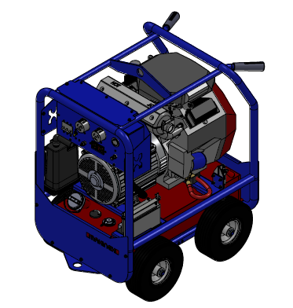

Rev 0321

**OPERATOR’S MANUAL**

Table of Contents

INTRODUCTION 1

DISCLAIMER 1

ABOUT THIS MANUAL 2

KEY TERMS 2

PRODUCT INFORMATION 3

PROPOSITION 65 WARNINGS 3

SAFETY INFORMATION 3

GENERAL SAFETY PRECAUTIONS 3

ELECTRICITY RELATED SAFETY PRECAUTIONS 5

EARTHING OF GENERATOR 6

SAFETY DECALS GEN-16P-MS-240 8

SAFETY DECALS GEN-16P-MS-480 9

PRODUCT SPECIFICATIONS 10

FEATURES 10

OVERALL MACHINE DIMENSIONS (MM) 11

ALTERNATOR SPECIFICATIONS 11

ELECTRICAL PANEL SPECIFICATIONS 13

OPERATION 14

BEFORE USE 14

ADDING FUEL 15

OPERATING GENERATOR 16

CONNECTING ELECTRICAL DEVICES 16

SHUTTING DOWN THE GENERATOR 16

MAINTENANCE 17

GENERAL RECOMMENDATIONS: 17

CHECK YOUR GENERATOR 17

STORAGE 18

LIMITED WARRANTY 19

NORMAL WEAR 20

INSTALLATION, USE, AND MAINTENANCE 20

OTHER EXCLUSIONS 20

CONTACT INFORMATION 22

APPENDIX A- RISK ASSESSMENT 23

APPENDIX B- WIRING DIAGRAMS 24

APPENDIX C – ALTERNATOR DIAGRAMS 26

# INTRODUCTION

Thank you for purchasing a MAKINEX product.

This manual provides information and procedures to safely operate and maintain the GEN-16P-MSGenerator. For your own safety and protection from injury, carefully read, understand, and observe the safety instructions described in this manual.

Keep this manual or a copy of it with the machine. If you lose this manual or need an additional copy, please contact MAKINEX. This machine is designed and built with user safety in mind; however, it can present hazards if improperly operated and serviced. Please follow the operating instructions carefully. If there are any questions regarding operating or servicing of this machine, please contact MAKINEX.

All rights, especially copying and distribution rights are reserved.

Copyright 2023 by MAKINEX.

No part of this publication may be reproduced in any form or by any means, electronic or mechanical, including photocopying, without express written permission from MAKINEX.

Any type of reproduction or distribution not authorised MAKINEX represents an infringement of valid copyrights and will be prosecuted. We expressly reserve the right to make technical modifications, even without due notice, which aim at improving our machines or their safety standards.

# DISCLAIMER

MAKINEX and its affiliates take no responsibility for any damage, injury or death resulting from the incorrect or unsafe use of this product. Use of this product should be undertaken by competent persons only. It is the operator’s responsibility to ensure that the following safety procedures are followed. If you are unsure, do not operate this product.

Record the model and serial numbers as well as date and place of purchase for future reference. Have this information available when ordering parts and when making technical or warranty inquiries

|  |
| --- |
| **MAKINEX SUPPORT** |
| **Refer to contact information on pg. 22** |
| **MODEL NO.** |
| **GEN-16P-MS-240 / GEN-16P-MS-480** |
| **SERIAL NO.** |
|  |
| **DATE OF PURCHASE** |
|  |
| **PURCHASE LOCATION** |

# ABOUT THIS MANUAL

This manual uses the following symbols to help differentiate between different kinds of information. The safety symbol is used with a key word to alert you to potential hazards in operating and owning power equipment. Follow all safety messages to avoid or reduce the risk of serious injury or death.

## KEY TERMS

|  |  |
| --- | --- |
| **READ CAREFULLY** | **READ CAREFULLY** – refers to ***important***  ***information*** that should be paid careful attention. |

|  |  |
| --- | --- |
| **CAUTION** | **CAUTION** - indicates a potential hazardous situation which, if not avoided, ***may***result in minor or moderate injury |

|  |  |
| --- | --- |
| **WARNING** | **WARNING** – indicates a potentially hazardous situation which, if not avoided, ***could*** result in death or serious injury |

|  |  |
| --- | --- |
| **DANGER** | **DANGER** – indicates an imminently hazardous situation which, if not avoided, ***will*** result in death or serious injury |

|  |  |
| --- | --- |
| **PROHIBITED** | **PROHIBITED** – identifies actions that ***should never*** be carried out by anyone interacting with the machine. |

# PRODUCT INFORMATION

## PROPOSITION 65 WARNINGS

|  |  |
| --- | --- |
| **WARNING** | **THIS PRODUCT CONTAINS LEAD, A CHEMICAL KNOWN TO THE STATE OF CALIFORNIA TO CAUSE BIRTH DEFECTS OR OTHER REPRODUCTIVE HARM.** |

|  |  |
| --- | --- |
| **WARNING** | **THIS PRODUCT CONTAINS ONE OR MORE CHEMICALS KNOWN TO THE STATE OF CALIFORNIA TO CAUSE CANCER, BIRTH DEFECTS OR OTHER REPRODUCTIVE HARM.** |

|  |  |
| --- | --- |
| **WARNING** | **EXHAUST GASES FROM THIS PRODUCT CONTAIN CHEMICALSKNWON TO THE STATE OF CALIFONIA TO CAUSE CANCER, BIRTH DEFECTS OR OTHER REPRODUCTIVE HARM.** |

***WASH HANDS AFTER HANDLING THIS PRODUCT***

## SAFETY INFORMATION

|  |  |
| --- | --- |
| **WARNING** | Read this manual **thoroughly** before operating your generator. Failure to follow instructions could result in serious injury or death |

|  |  |
| --- | --- |
| **WARNING** | MAKINEX GEN-16P-USA Generator designed for professional operators only, instruct operators in care and use of the machine before use! |

### GENERAL SAFETY PRECAUTIONS

* **ALWAYS** use in a well-ventilated area.
* **ALWAYS** ensure the applied load does not exceed the generators rating.

Overloading the generator is dangerous and could cause serious damage.

* **ALWAYS** disconnect the generator when carrying out any maintenance.
* **ALWAYS** ensure the generator reaches operating speed before connecting

a load.

* **ALWAYS** start the engine BEFORE connecting any appliances to the output

receptacles.

* **ALWAYS** test the GFCI’s before use.
* **ALWAYS** check the generator for damage before use.
* **ALWAYS** keep well clear of all moving parts on the generator at all times.
* **NEVER** allow children or animals near the generator.
* **NEVER** connect to a commercial or mains power supply, or any other

electrical source.

* **NEVER** allow the generator to run out of fuel when a load is connected.
* **NEVER** alter or tamper with the internal wiring of the generator.
* **NEVER** climb or stand on the generator as dents may cause overheating of

the acoustic lining.

* **NEVER** touch any part of the engine, alternator, or exhaust when the generator is in use as these get hot and could burn.

|  |  |
| --- | --- |
| **DANGER** | **RISK OF EXPLOSION OR FIRE**   * Fuel and its vapours are extremely flammable and explosive * Fire or explosion can cause severe burns or death |

* **ALWAYS** switch the engine OFF when refuelling.
* **ALWAYS** refuel away from any source of heat.
* **ALWAYS** refuel in a well-ventilated area.
* **NEVER** overfill fill the tank, fill to the level specified.
* **NEVER** smoke whilst refuelling and avoid smoking or using a naked flame

near the generator.

* **NEVER** start the engine if there is a fuel spill. Any spillage must be wiped

clean and the generator allowed to dry before attempting to start the engine.

|  |  |
| --- | --- |
| **DANGER** | **RISK TO BREATHING**   * Running engine gives off Carbon Monoxide, an odourless, colourless, poisonous gas. * Breathing Carbon Monoxide can cause nausea, fainting or death. * Some chemicals or detergents may be harmful if inhaled or ingested, causing severe nausea, fainting, or poisoning. |

***WARNING: EXHAUST FUMES CAN BE FATAL***

* **ALWAYS** ensure that there is adequate ventilation when using the generator.
* **ALWAYS** position the generator so that the exhaust is pointing away from

people or animals.

* **NEVER** use the generator indoors or in an enclosed area. (i.e. in warehouse,

tunnel, well or a hold).

### ELECTRICITY RELATED SAFETY PRECAUTIONS

|  |  |
| --- | --- |
| **WARNING** | **RISK OF ELECTRICAL SHOCK**   * + Risk of electrocution. |

* **ALWAYS** test the GFCI’s before use.
* **ALWAYS** store the generator undercover when not in use and away from

damp or wet conditions.

* **NEVER** use the generator outdoor when it is raining or snowing or in wet or damp conditions.
* **NEVER** use water or any other liquids to clean the unit while it is running.

|  |  |
| --- | --- |
| **DANGER** | **RISK OF HOT SURFACES**   * Contact with hot surfaces, such as engine’s exhaust components, could result in serious burns. |

* During operation, touch only the control surfaces of generator. Keep children away from the generator at all times. They may not be able to recognise the hazards of this product.

|  |  |
| --- | --- |
| **WARNING** | **POSITIONING THE GENERATOR FOR USE** |

* **ALWAYS** leave at least a 3-foot gap between the generator and any

surrounding building or structure.

* **ALWAYS** ensure the generator is on a solid, flat surface.
* **ALWAYS** ensure the surrounding area is free from any material that could

burn or be damaged by heat.

* **NEVER** move or tilt the generator whilst it is switched on.
* **NEVER** cover or enclose the generator whilst it is in use.
* **Be** **aware** of the weight of the generator, do not attempt to lift or move the

generator without the assistance of other persons or suitable lifting equipment.

## EARTHING OF GENERATOR

Earthing of generators helps protect the user from electric shock or electrocution which may be caused due to malfunction or breakdown. This threat to the user is prevented by creating a path of least resistance for the electrical current to travel to the ground which inherently absorbs the over-current or short circuit.

|  |  |
| --- | --- |
| **warning%201**  **WARNING** | **FAILURE TO PROPERLY CONNECT THE EQUIPMENT TO THE EARTHING CONDUCTOR WILL RESULT IN A RISK OF ELECTROCUTION. CONSULT WITH A QUALIFIED ELECTRICIAN INCASE OF DOUBT WITH THE EARTHING OF THE UNIT.** |

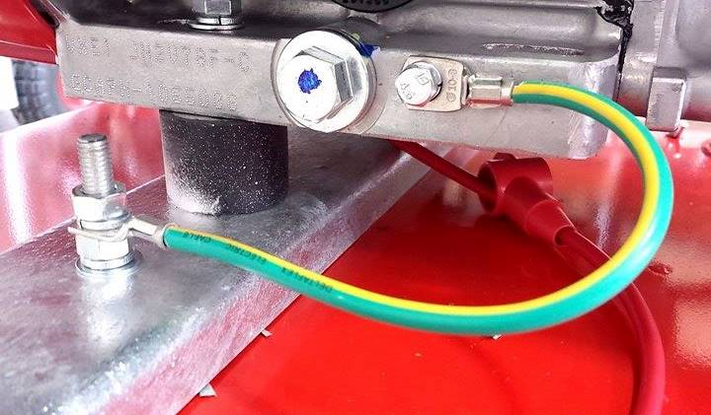To connect the generator to an appropriate earth source, a hex nut and an earth terminal should be used. A #8 earth wire must be used to establish the earth path for the electrical current. Connect the terminal of one end of the earth wire to the frame in-between a spring washer and two hex nuts then tighten the nuts securely. The other end of the wire should be bolted securely onto an appropriate ground source.

Portable generators are inherently more dangerous than fixed generators as they are not permanently earthed. Therefore, appropriate measures must be taken to properly set up the earthing of the generators. The National Electric Code (NEC) contains several methods that can be used to establish a suitable earthing source for the portable generator unit. Some examples of these methods are summarised in the following points.

* A suitable earthing source can be a metal underground water pipe in direct contact with the earth at a minimum depth of 10 feet.
* If a pipe is unavailable, an 8-foot length pipe or rod can also be used as a suitable earthing source.
* Pipes used as an earthing source must be 3/4-inch trade size or larger with a non-corrosive outer surface.
* Steel or iron rods must be at least 5/8 diameter, and at least 1/2-inch diameter for non-ferrous rods. Ensure that the non-ferrous material used is earthing suitable.
* Rod or pipe should be driven 8 feet deep into the ground. If a rock bottom is met within 4 feet, the rod or pipe can be buried in a trench.
* All electrical tools and appliances powered by the generator, must be properly earthed by either a third wire or “double insulated”.

**Recommendations:**

1. Use electrical devices with 3-prong power cords
2. Use extension cords with a 3-hole receptacle and a 3-prong plug on opposite ends to maintain earth protection from the generator to the appliance.

We strongly recommend that all applicable federal, state, and local regulations relating to grounding/earthing specifications be checked and followed.

**THIS INSTALLATION MUST BE CARRIED OUT BY A LICENSED ELECTRICIAN AND ALL LOCAL CODES MUST BE FOLLOWED.**

## SAFETY DECALS GEN-16P-MS-240

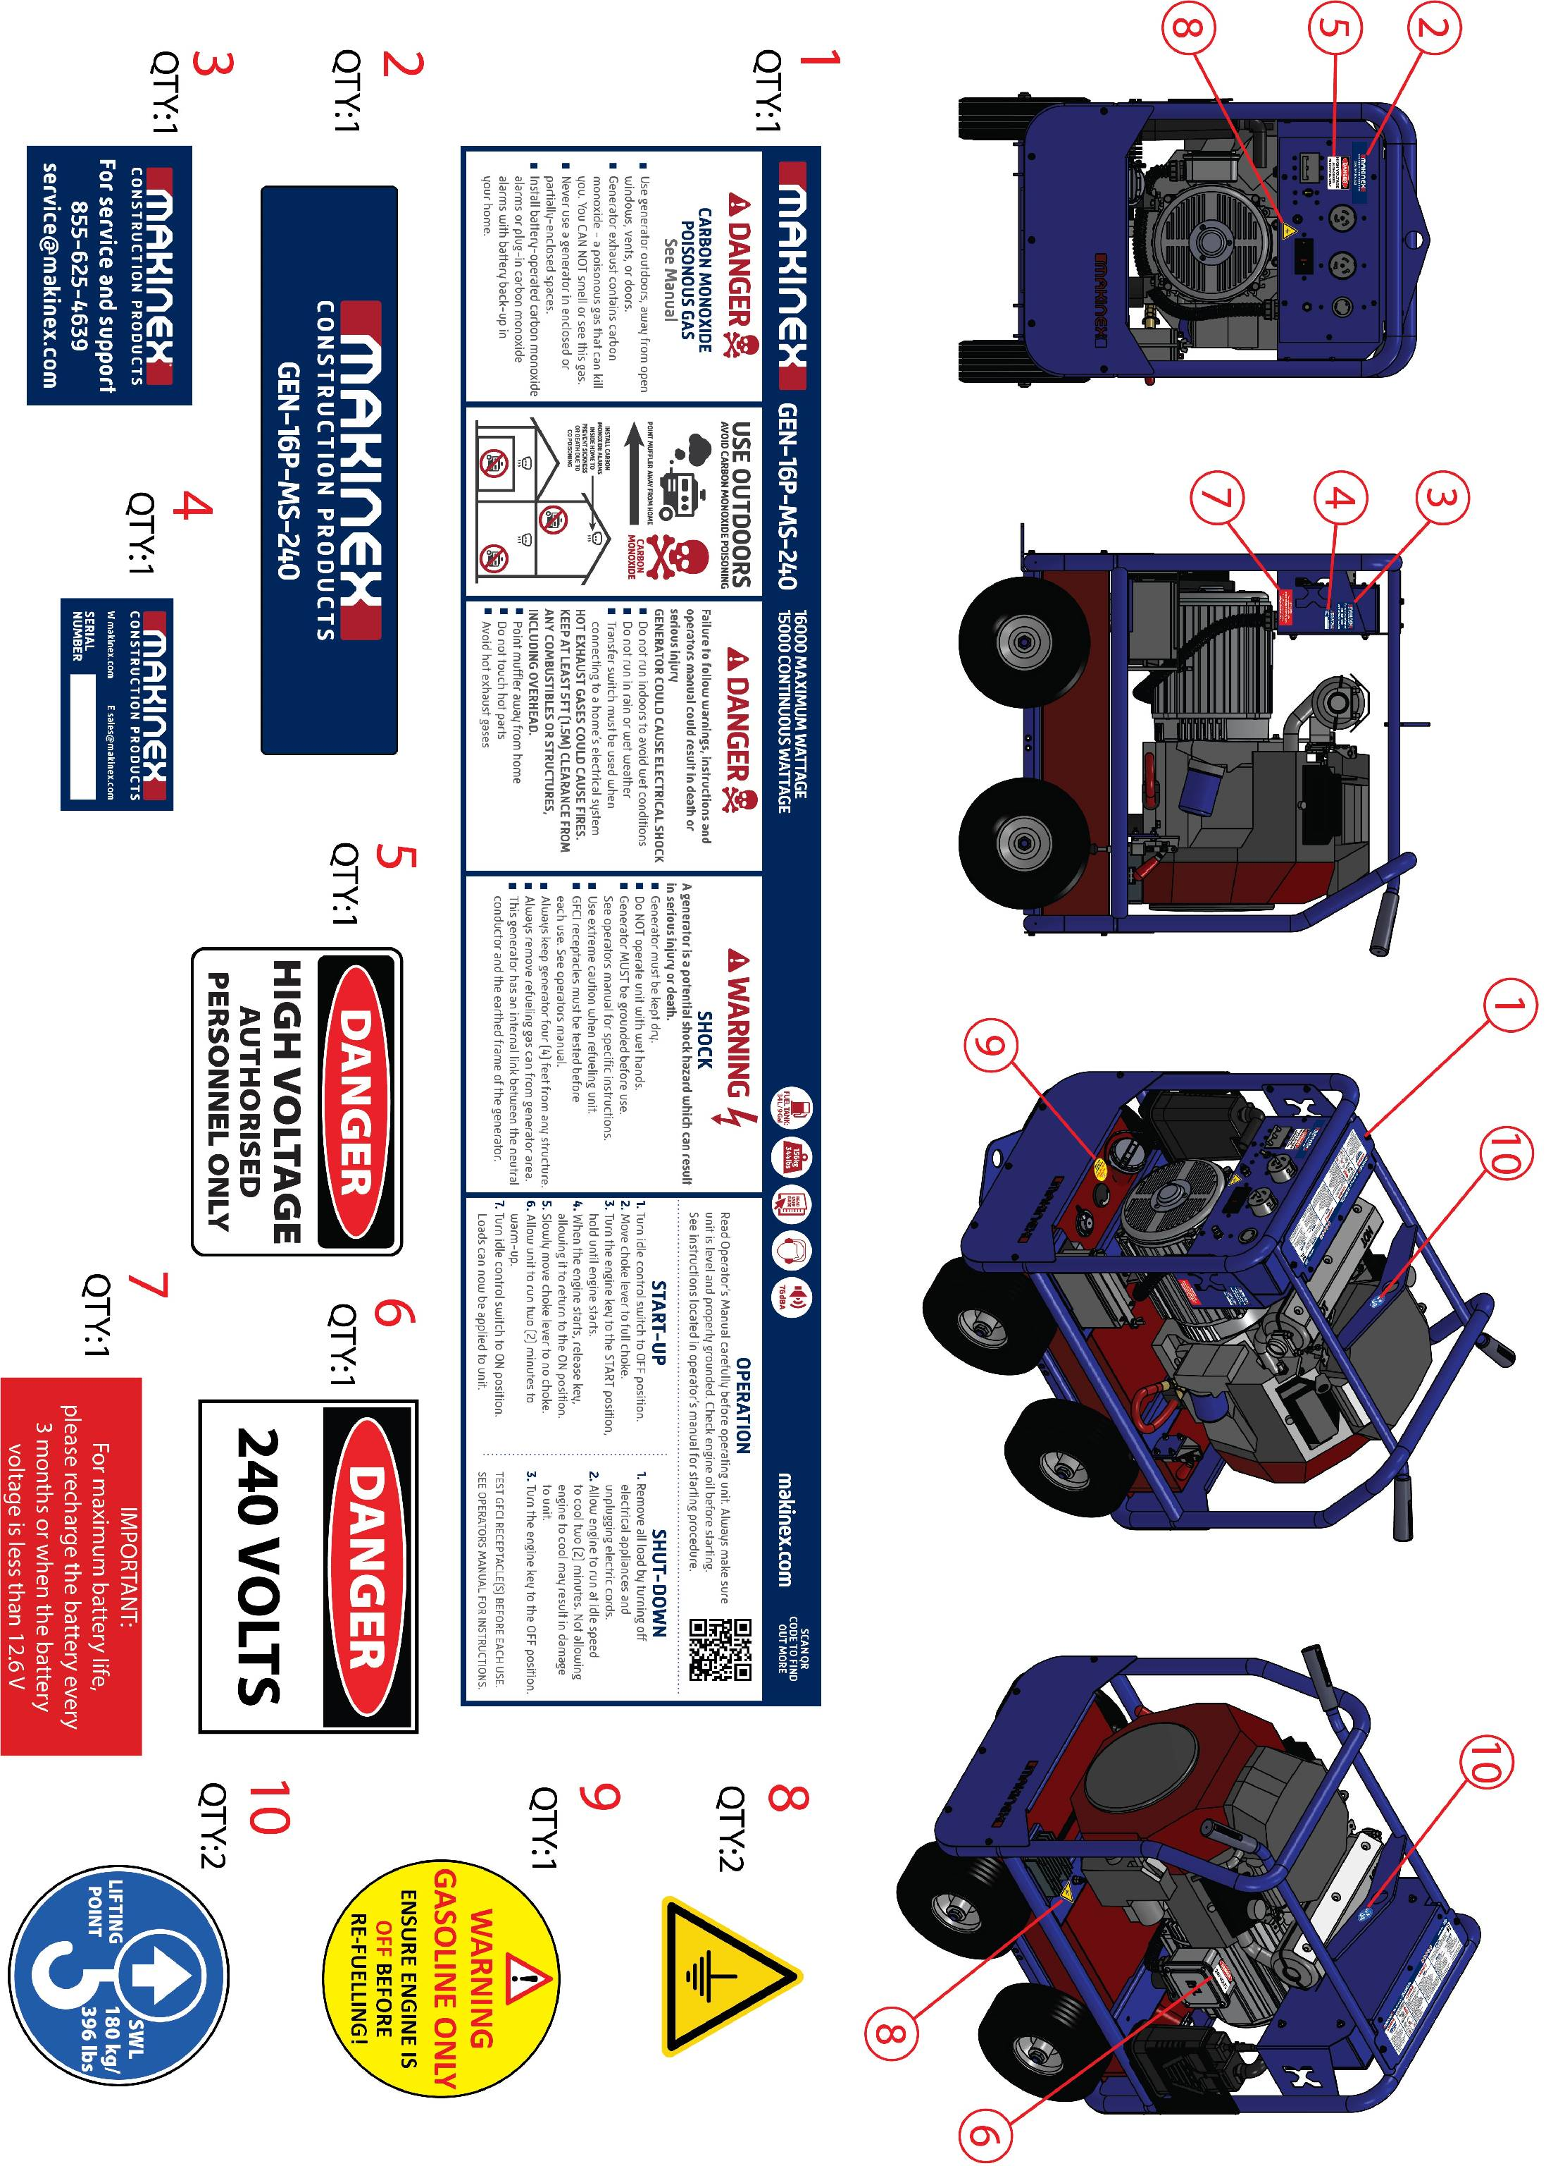

## SAFETY DECALS GEN-16P-MS-480

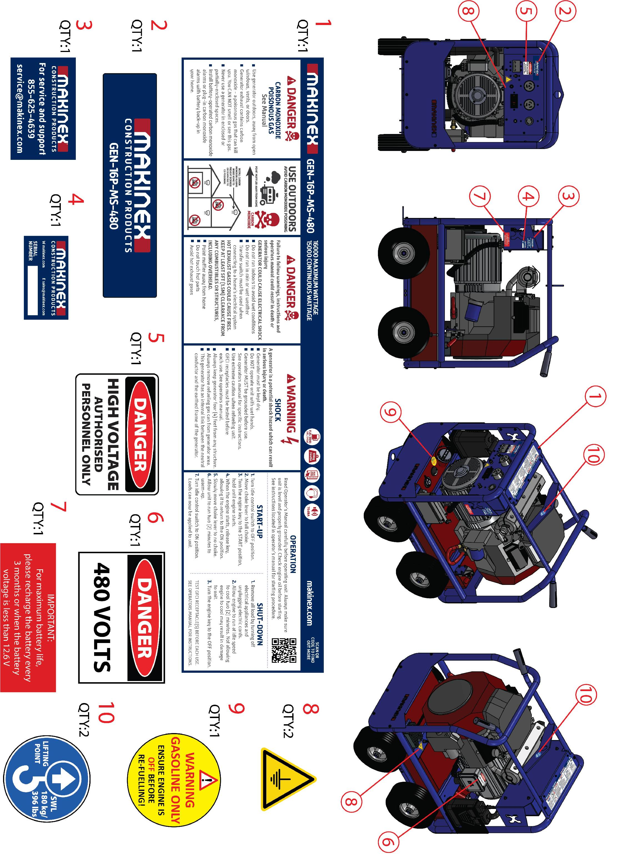

*May vary by model

# PRODUCT SPECIFICATIONS

|  |  |  |
| --- | --- | --- |
| **GENERATOR:** | **240V** | **480V** |
| MAX OUTPUT | 16kW | |
| FREQUENCY | 60Hz | |
| VOLTAGE | 120/240V | 120/480V |
| CONTINUOUS OUTPUT | 14,800W | 15,200W |
| SOCKETS (with GFCI protection) | 2X50A, 1X30A and 2X20A | 1x30A (parallel),1x30A, 2x20A |
| WEIGHT | 155 kg (344 lbs) | |
| NOISE LEVEL (7M) | NO LOAD - 72dB | |
| 50% LOAD - 76dB | |
| 100% LOAD - 78dB | |
| RATED POWER FACTOR | 0.8 | |
|  | | |
| **ENGINE:** |  | |
| TYPE | TWIN CYLINDER AIR COOLED PETROL | |
| MODEL | HONDA GX690 | |
| STARTING SYSTEM | KEY START | |
| DISPLACEMENT | 688CC | |
| FUEL ECONOMY | 3.5 L (0.92 gallon)/h @ 50% LOAD | |
| FUEL TANK | 34 L (9 gallon) | |



## FEATURES

|  |
| --- |
| **FEATURES** |
| Durable powder coated frame |
| Multi cushion isolators for vibration reduction |
| Compact design for easy storage and transport |

## OVERALL MACHINE DIMENSIONS (INCHES)

## ALTERNATOR SPECIFICATIONS

**120/240V**

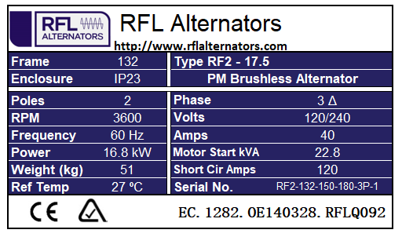

**240/480V**

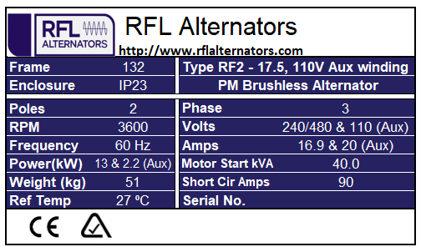

## ELECTRICAL PANEL SPECIFICATIONS

20A 125V GFCI RECEPTACLE

20A PUSH BUTTON OVERLOAD DEVICE

30A 125/250V RECEPTACLE

50A 125V/250V RECEPTACLE

3P 50A 250V RECEPTACLE

3P 50A BREAKER

2P 30A BREAKER

**240V**

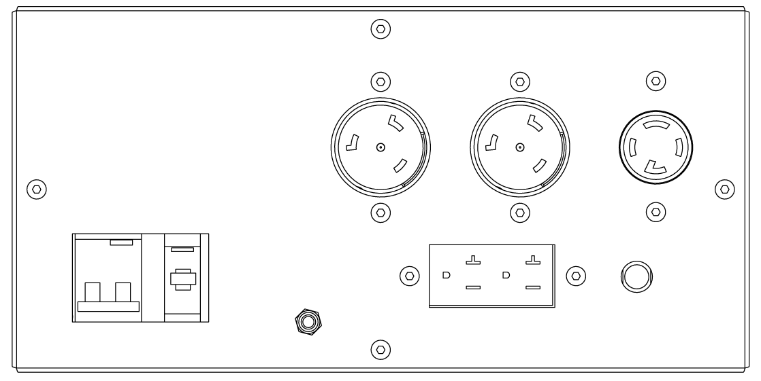

20A 125V GFCI RECEPTACLE

20A PUSH BUTTON OVERLOAD DEVICE

30A 125/250V RECEPTACLE

50A 125V/250V RECEPTACLE

3P 50A 250V RECEPTACLE

GROUND

2P 30A BREAKER

3P 50A BREAKER

**480V**

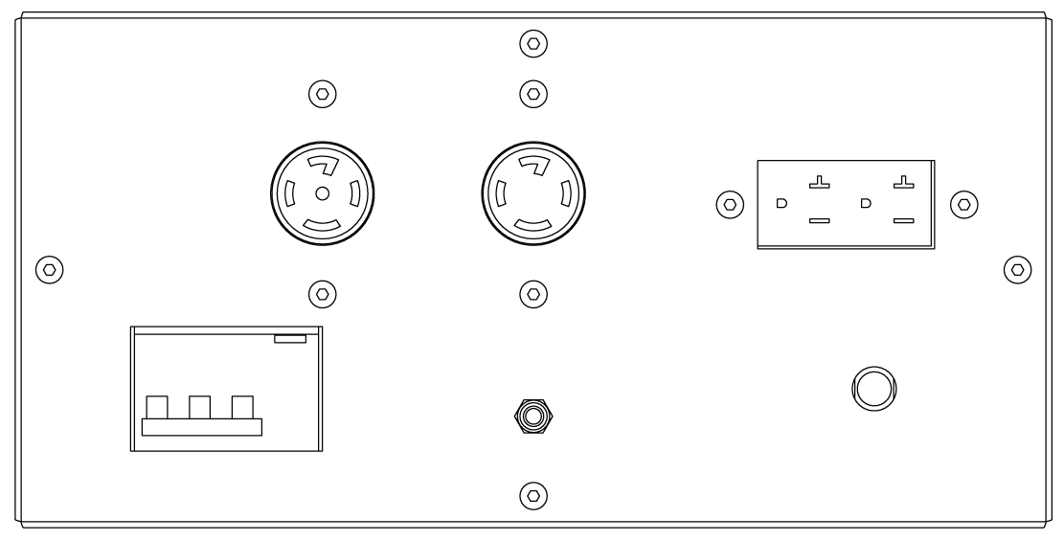

20A PUSH BUTTON OVERLOAD DEVICE

GROUND

3P 30A 480V BREAKER

20A 125V GFCI RECEPTACLE

3P 30A 480V RECEPTACLE

3P 30A 480V RECEPTACLE (PARALLEL)

# OPERATION

## BEFORE USE

Oil Level Check (New machines will be pre-oiled from MAKINEX)

*Check the engine oil level with the engine stopped and, in a level, position.*

1. Start the engine and let it idle for 1 or 2 minutes. Stop the engine and wait for 2 or 3 minutes.
2. Remove the oil level dipstick and wipe it clean.
3. Fully insert the oil level dipstick, then remove it to check the oil level.
4. If the oil level is low, remove the oil filler cap, and fill with the recommended oil to the upper limit mark on the oil level dipstick.
5. Reinstall the oil level dipstick and oil filler cap.

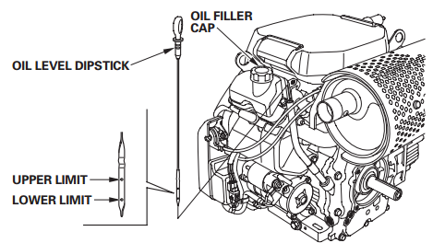

## ADDING FUEL

|  |  |
| --- | --- |
| **WARNING** | **FAILURE TO USE FUEL AS RECOMMENDED IN THIS MANUAL WILL VOID WARRANTY** |

-DO NOT use unapproved gasoline such as E85 (85% ethanol/15% gasoline).

-DO NOT mix oil with gasoline.

-DO NOT modify engine to run on alternate fuels.

|  |  |
| --- | --- |
| **WARNING** | **Fuel and fuel vapour are extremely flammable and explosive. Fire or explosion from misuse of fuel can cause severe burns and even death.** |

**WHEN ADDING FUEL TO GENERATOR, OBSERVE THE FOLLOWING STEPS:**

2.0 Always ensure that fuel tanks are filled outdoors.

2.1 Turn generator OFF and let it cool for at least two minutes before removing fuel cap.

2.2 Loosen fuel cap slowly to release pressure.

2.2 Slowly add unleaded gasoline to fuel tank. DO NOT fill fuel above baffle. This allows appropriate space for fuel expansion.

2.3 Wait for spilled fuel to evaporate before starting the engine.

2.5 Keep fuel away from sparks, open flames, pilot lights, heat and other ignition sources.

2.6 DO NOT light a cigarette or smoke near open fuel tank or container.

# OPERATING GENERATOR

**STARTING THE ENGINE**

1. Remove all connections from the AC sockets.

2. If the fuel tank is equipped with a valve, be sure the fuel valve is in the OPEN or ON position before attempting to start the engine.

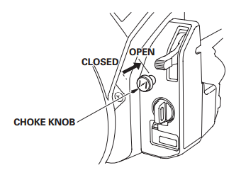

3. To start a cold engine, pull the choke knob out to the CLOSED position. To restart a warm engine, leave the choke knob in the OPEN position.

4. Turn the engine switch to the START position and hold it there until the engine starts.

5. When the engine starts, release the engine switch, allowing it to return to the ON position.

6. Once the engine has warmed up, set the choke lever to the OPEN position.

## CONNECTING ELECTRICAL DEVICES

The generator can supply 120V AC through 2 x 20amp sockets or 120V AC through 2 x 30amp sockets and 208V AC through the 50A sockets.

1. Connect the appliance to the generator starting with the device that draws the most current.

2. Set the circuit breaker to ‘ON’.

## SHUTTING DOWN THE GENERATOR

1. Disconnect all appliances connected to the generator.

2. Turn the ignition key to the OFF position.

3. Set the fuel supply valve to OFF if the fuel tank equipped with.

**NOTE:** To stop the generator in an emergency simply turn the ignition key to the off position.

MAINTENANCE

## GENERAL RECOMMENDATIONS:

Regular maintenance will improve the performance and extend the life of the GENERATOR.

The generator’s warranty does not cover items that have been subjected to operator abuse or negligence. To receive full value from the warranty, the operator must maintain the generator as instructed in this manual and in the engine manual, including proper storage.

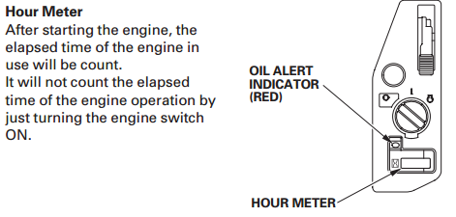

**NOTE:** An hour meter is installed on the machine to help with tracking operation hours.

**Refer to Honda GX690 user manual *(provided at sale)* for engine related maintenance.**

Should you have questions about replacing components on your generator, please contact dealer for assistance.

## CHECK YOUR GENERATOR

It is considered good practise to inspect a generator before and after use, looking at:

* Condition of tyres
* Function of brake
* Condition of electrical components
* Earthing bolts are tight
* All 4 generator mounting bolts are tight
* Fuel lines are not damaged
* Oil and fuel levels
* Battery is well secured, and terminals are fastened tightly

# STORAGE

**Long term storage instructions (fuel in tank)**

Gasoline fuel can become stale when stored over 30 days. Stale fuel causes acid and gum deposits to form in the fuel system or crucial carburettor parts. To keep fuel fresh, add a fuel stabiliser liquid additive to fuel. The fuel stabiliser is available at most auto parts stores.

Draining gasoline is unnecessary if the fuel stabiliser is used according to the instructions that come with it. Run engine for a minimum of two minutes, after stabiliser is added to fuel, to allow it to circulate throughout the engine. The engine and fuel can be stored up to 24 months.

|  |  |
| --- | --- |
| **WARNING** | Fuel and fuel vapour are extremely flammable and explosive. Fire or explosion from misuse of fuel can cause severe burns and even death. |

**To protect against rust formation during storage, oil the cylinder bore:**

1. Remove spark plugs and pour approx. 15ml (1/2oz) of clean engine oil into the cylinder.
2. Install spark plug and briefly turn key starter for 1-2 seconds to distribute oil. **DO** **NOT** start engine at this time.

|  |  |
| --- | --- |
| **WARNING** | Unintentional sparking can cause fire or electrical shock. Failure to observe this warning can cause severe property damage, severe burns and even death.  Disconnect spark plug wire from spark plug and cover tip of spark plug wire with insulating tape and place wire where it cannot come in contact with spark plug or generator frame. |

|  |  |
| --- | --- |
| **WARNING** | Certain storage covers can be flammable or can melt in high temperatures. DO NOT place storage cover over generator until it has completely cooled. |

# LIMITED WARRANTY

In order to take advantage of the MAKINEX limited warranty, you must have maintenance performed according to the schedule (contained in relevant owner’s manual supplied with this product), by an authorised MAKINEX dealer or MAKINEX service technician. You are free to have your MAKINEX product serviced by any suitably qualified mechanic or electrician (depending on the mechanical or electrical requirement) and this will not affect your statutory warranties, however, failure by the owner to have the recommended servicing carried out by an authorised MAKINEX dealer/service technician means that you cannot take advantage of the MAKINEX limited warranty.

In order to ensure your safety, we strongly recommend that you only use an authorised MAKINEX dealer for servicing. Only authorised MAKINEX dealers have access to all the special tools, technical information, parts and training required to maintain your MAKINEX product in peak operating condition.

MAKINEX warrants each new Generator to be free from defects in material and workmanship under normal domestic and industrial use and service for the period specified below, conditional to the limitations and exclusions printed on this page. This warranty applies only to new MAKINEX generator distributed by us and by our authorised MAKINEX dealers.

**WARRANTY: (Ex-factory/ Reseller premise)**

MAKINEX warrants to the original purchaser:

* + Frame and all Electrical components will be free of defects in material and workmanship for a period of one (1) year from the original date of purchase.
  + Honda GX Engine is subject to (3) years warranty. Please see www.hondapowerequipment.com for details.
  + One (1) year warranty on RFL alternators.
  + 1-year warranty for electrical components.

**WARRANTY EXCLUSIONS**

This warranty does not cover the following repairs and equipment:

## NORMAL WEAR

Generator needs periodic parts and service to perform well. This warranty does not cover repair when normal use has exhausted the life of a part or the equipment as a whole.

## INSTALLATION, USE, AND MAINTENANCE

This warranty will not apply to parts and/or labour if this generator is deemed to have been misused, neglected, involved in an accident, abused, loaded beyond the generator’s limits, modified and installed improperly. Normal maintenance such as spark plugs, air filters, adjustments, fuel system cleaning and obstruction due to build-up is not covered by this warranty.

## OTHER EXCLUSIONS

This warranty excludes:

* Cosmetic defects such as paint, decals, etc.
* Accessory parts such as starting batteries, and storage covers.
* Failures due to acts of God and other force majeure events beyond the manufacturer’s control.
* Problems cause by parts that are not original MAKINEX parts.

**Responsibility of the consumer under this Limited Warranty:**

* Strict adherence to the maintenance checks and schedule with proof of scheduled maintenance service required by an authorised agent or qualified mechanic.
* Maintenance services are not covered under warranty.
* It is the consumer’s responsibility to deliver the machine in question to our service premises or to the premises of our appointed agent at the consumer’s expense for replacement or repair as applicable.

**Claim Procedure:**

* Contact MAKINEX by phone or email informing us of your machines problem or defect.
* Once the extent of the claim has been assessed, we retain the right to compensate the consumer for such defect, or repair (parts & labour), or replace the machine under warranty.
* All warranties will be carried out by MAKINEX authorised staff or appointed agents at a premise to be determined by the Manufacturer.
* Where the specific warranty component (e.g. Engine) is under a Manufacturer’s warranty other than MAKINEX (e.g. Honda, Hatz or Kohler etc.), the consumer can either contact MAKINEX or the applicable Manufacturer for repairs where such warranty was registered with that manufacturer at purchase.
* Warranty calls will only be carried out by our representatives and not via client’s choice of repairer. We will not accept back charges for any work not carried out by our representatives or accept any charges due to equipment being un-operational for any reason even during its warranty period.

# CONTACT INFORMATION

For sales, service, warranty and part orders, please call

|  |  |
| --- | --- |
|  | **SALES, SERVICE, SPARE PARTS & WARRANTY** |
| **AUSTRALIA** | **SALES**  **TEL** 1300 795 953 or  +61 2 9460 8071  **WEB** www.makinex.com.au  **SERVICE, SPARE PARTS & WARRANTY**  **EMAIL** [service@makinex.com.au](mailto:service@makinex.com.au) |
| **USA** | **SALES**  **TEL** +1 855-625-4639  **WEB** [www.makinex.com](http://www.makinex.com)  **SERVICE, SPARE PARTS & WARRANTY**  **EMAIL** [service@makinex.com](mailto:service@makinex.com) |
| **UK** | **WEB** [www.makinex.co.uk](http://www.makinex.co.uk) |
| **EUROPE** | **TEL** +31 (0)6 24881203 or  +31 (0)6 50841849  **EMAIL** [info@mtools.eu](mailto:info@mtools.eu) |
| **CHINA** | **TEL** +8618951118278  **EMAIL** [sales@makinex.com.cn](mailto:sales@makinex.com.cn) |

**Or your nearest MAKINEX distributor**

pgAPpZJvLlfbT9J8-1We have very knowledgeable, experienced staff to assist you with help and advice.

## APPENDIX A- RISK ASSESSMENT

|  |  |  |  |
| --- | --- | --- | --- |
| **PRODUCT RISK/ RISK HAZARDMENT ASSESSMENT** | NATHAN MCMILLIAN | **002** | **02/05/2017** |
| **ASSESSMENT CARRIED OUT** | **DOCUMENT REVISION** | **DATE CREATED** |
| GEN-16P-US-208 | MAKINEX | PLANT LICENCE NOT REQUIRED |
| **PRODUCT NAME:** | **MANUFACTURER:** | **OPERATOR COMPETENCY:** |

|  |  |  |  |  |  |  |
| --- | --- | --- | --- | --- | --- | --- |
| **CONTROL ACTION** | * BE CAUTIOUS OF HOT PARTS (SUCH AS MUFFLER). * ALLOW TO COOL BEFORE MAINTENANCE/ ADJUSTMENTS | * SHUT OFF MACHINE AND ALLOW TO COOL BEFORE REFUELIING. * NEVER REFUEL WHILE MOTOR IS RUNNING. * DO NOT SMOKE AND ENSURE REFUELING IS UNDERTAKEN IN A WELL-VENTILATED AREA. (OUTSIDE, CLEAR OF IGNITION SOURCE. | * ENSURE THAT NO PART OF BODY IN CONTACT WHEN TERMINALS WHEN STARTING/ USING GENERATOR | * STAFF TRAINING CORRECT LIFTING PROCEDURE | * MANUAL HANDLING TECHNIQUE | * ALWAYS WEAR HEARING PROTECTION WHILST OPERATION AND/ OR IN CLOSE VINCINITY OF THE MACHINE |
| **RISK LEVEL** | LOW | MEDIUM | HIGH | HIGH | LOW | MEDIUM |
| **4** | **3** | **2** | **2** | **4** | **3** |
| **CONDEQUENCE** | NEGLIGIBLE | MAJOR | FATALITY | MAJOR | MINOR | MINOR |
| **4** | **2** | **1** | **2** | **3** | **3** |
| **LIKELIHOOD** | LIKELY | UNLIKELY | UNLIKELY | LIKELY | UNLIKELY | UNLIKELY |
| **2** | **3** | **3** | **2** | **3** | **3** |
| **TYPE/ NATURE OF RISK or HAZARD** | PERSONAL INJURY – BURNS WHILIST PERFORMING MAINTENANCE ON MACHINE | FIRE/EXPLOSION WHILST REFUELING ENGINE | LOW RISK OF POSSIBLE MINOR BURNS FROM MAINS ELECTRICAL CONNECTIONS ON GENERATOR | PERSONAL INJURY WHEN LIFTING/ OR MOVEMENT ON SITE | STRATING PORTABLE GENERATOR | HEARING DAMAGE DUE TO LONG TERM USE |
| **1.1** | **1.2** | **2.1** | **3.1** | **3.2** | **4.1** |
| **BURNS/FIRE** |  | **ELECTROCUTION** | **ERGONOMIC INJURY** |  | **NOISE** |
| **No.** | **1.0** |  | **2.0** | **3.0** |  |  |

**NOTES:**

> THIS PRODUCT HAS BEEN DESIGNED AND MANUFACTURED AS A HAND TRUCK WITH A POWERFUL LIFTING ARM ONLY

> THIS DOCUMENT HAS BEEN PREPARED ACCORDING TO GUIDELINES AND RECOMMENDATIONS FOUND IN:

1. 'HAZPAK' PRODUCED BY THE WORK‐COVER AUTHORITY AND

2. THE AUSTRALIAN STANDARDS 4024.1.4/5 ‐ 1996 "SAFEGUARDING OF MACHINERY ‐ PART 1: GENERAL PRINCIPLES AUSTRALIAN STANDARD, AS/NZS 3760 IN-SERVICE SAFETY INSPECTION AND TESTING OF ELECTRICAL EQUIPMENT.

**"LIKELIHOOD LEVEL"** REFERS TO THE PROBABILITY OF AN EVENT HAPPENING. THE FOLLOWING SCALE HAS BEEN USED TO DESCRIBE THE LIKELIHOOD OF A DEFINED RISK / HAZARD EVENT OCCURING DURING NORMAL OPERATION OF THE EQUIPMENT. NOTE THAT LIKELIHOOD EVALUATION IS QUALITATIVE AND BASED ON BEST ESTIMATION VIA CONSULTATION AND EXPERIENCE:

1. **VERY LIKELY**

2. **LIKELY**

3. **UNLIKELY**

4. **VERY UNLIKELY**

**"CONSEQUENCE**" REFERS TO THE SEVERITY OF INJURY CAUSED DUE TO AN EVENT OCCURING, USING THE FOLLOWING SCALE AS DEFINED BY THE "HAZPAK" DOCUMENT:

1. **FATALITY** = INJURIES RESULT IN DEATH

2. **MAJOR** = NORMALLY IRREVERSIBLE INJURIES

3. **MINOR** = REVERSIBLE INJURIES REQUIRING SEVERAL DAYS OFF

4. **NEGLIGIBLE** = ABLE TO BE TREATED USING FIRST AID

**"RISK LEVEL"** REFERS TO THE SEVERITY OF A RISK BASED ON THE "LIKELIHOOD LEVEL" AND "INJURY LEVEL”. INHERENTLY, AS THE CONSEQUENCE INCREASES IN SEVERITY, RISK INCREASES ‐ EVEN WHEN LIKELIHOOD IS LOW ‐ THE FOLLOWING SCALE HAS BEEN USED:

1. **HIGH** = POTENTIAL DEATH, PERMANENT DISABILITY, OR MAJOR STRUCTURAL DAMAGE.

2. **MEDIUM** = POTENTIAL TEMPORARY, DISABILITY, OR MINOR STRUCTURAL DAMAGE.

3. **LOW** = POTENTIAL INCIDENT THAT HAS THE POTENTIAL TO CAUSE PERSONS TO REQUIRE FIRST AID.

## APPENDIX B- WIRING DIAGRAMS

**240V WIRING DIAGRAM**

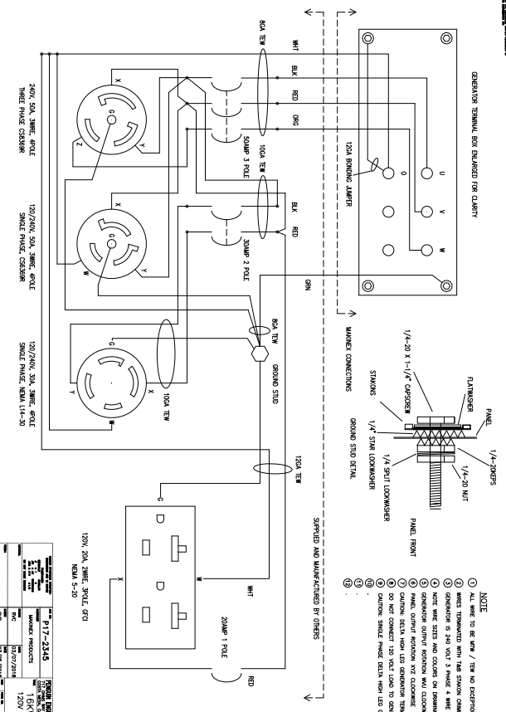

**480V WIRING DIAGRAM**

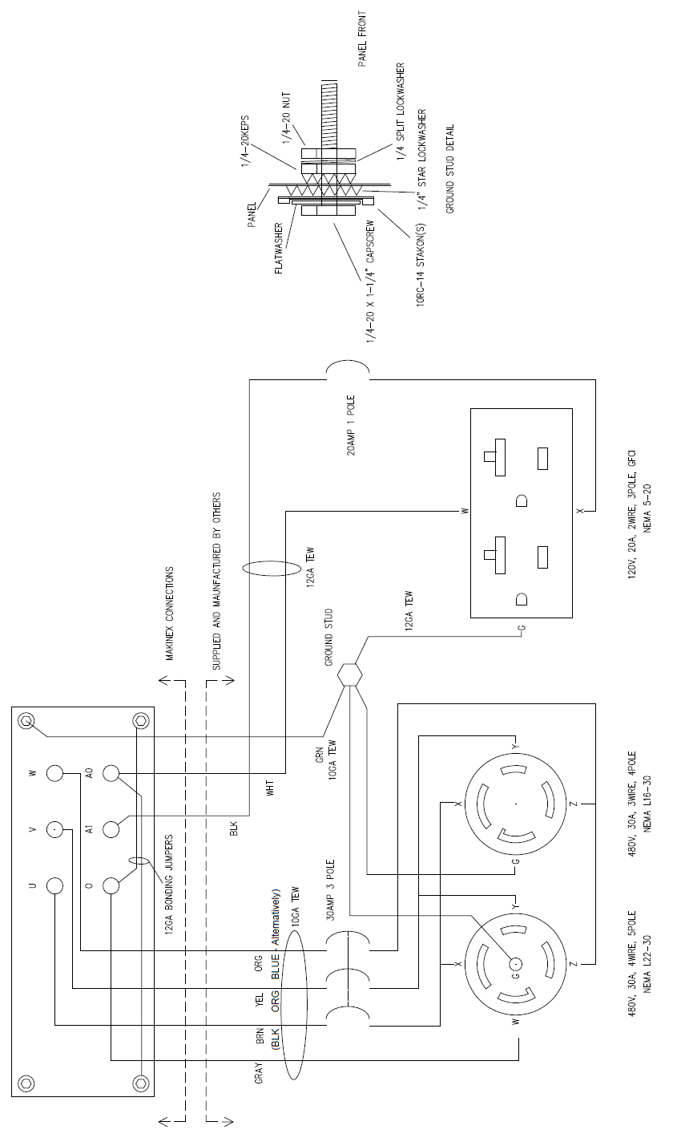

## APPENDIX C – ALTERNATOR DIAGRAMS

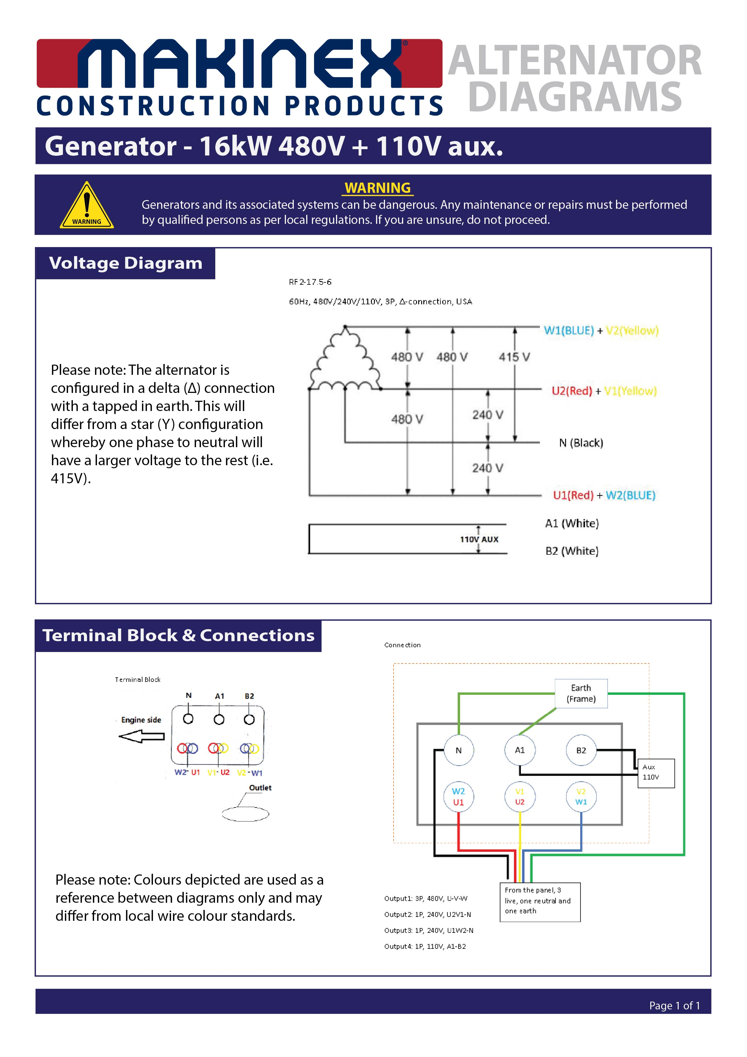

pgAPpZJvLlfbT9J8-1