**WH-50 Water Heater**

**Product Description and Specification**

WH-50 is an Electric Water Heater that heats and stores water in its tank, ready for use for items like a portable shower.

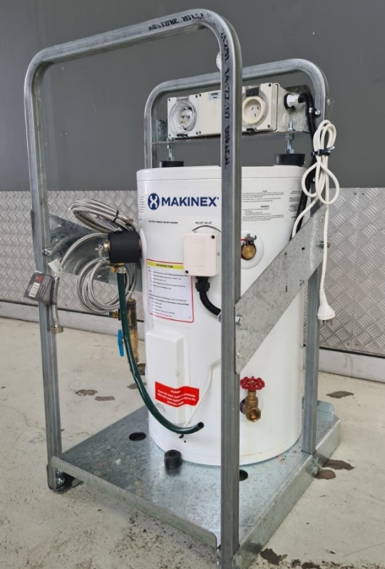.

|  |  |
| --- | --- |
| **WATER HEATER DIMENSIONS:** | |
| OVERALL WEIGHT | 53KG |
| HEIGHT | 1000mm |
| WIDTH | 530mm |
| DEPTH | 582mm |
| **MAKINEX WATER HEATER UNIT** | |
| TANK CAPACITY | 50L |
| RELIEF VALVE PRESSURE | 1000 KPA |
| RATED PRESSURE | 1000 KPA |
| MAX SUPPLY PRESSURE | 800 KPA |
| IP RATING | 34 (heater), 56 (low water cutout system) |
| POWER INPUT | 240V 10A ~50hz 2.4 kW |

# 

STEP 1 – INSTALLATION INSTRUCTIONS FOR THE WH-50

|  |  |
| --- | --- |
| **WARNING** | Do not adjust tempering valve. Water temperature must be set to maximum of 50°C. |

1. Ensure heater unit is sitting on a firm level surface which will not gather free water.
2. Connect **Hot** and **Cold** water braided hoses to the shower unit.
3. Connect 12mm garden hose to the **garden hose connector**. Ensure non-return valve tap is open (blue tap handle as shown in diagram is running along the line of the pipe to which it is fitted).
4. To fill, open **Hot** water tap on shower unit to allow air to purge from hot water heater when water supply is turned on.
5. Turn on water supply to hot water unit.
6. When water flows from shower head close the **Hot** water tap on shower unit. The heater and piping has now had air purged from it, is full of water and with the water supply on, unit is ready for use.
7. Plug in an RCD protected extension led to **power inlet.**
8. Plug in heater unit cord to the onboard **heater plug outlet. Do not plug this lead into any other outlet as heater protection systems will not operate and heater may be damaged.**
9. Switch power on. **The heater will not operate unless it has been purged as described above**.
10. To reduce risk of water loss from failure of supply hose couplings, water supply can be turned off when not in use and water in unit will stay heated. Turn water on prior to use.

Heater Plug Outlet

240V 10A Inlet

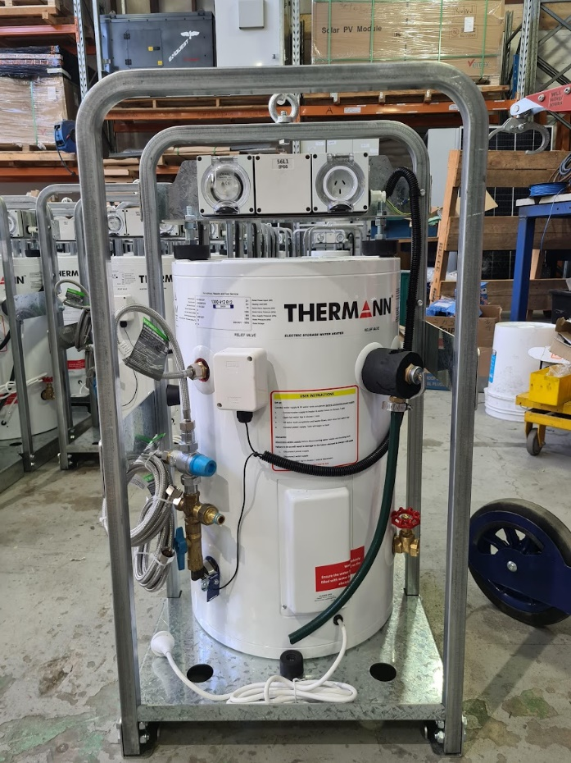

Float Sensor

Hot Water Out

Cold Water Out

Pressure Relief Valve

Water Drainage Valve

12mm Garden Hose Water Supply

One Way Valve

Tempering Valve

STEP 2 – TRANSPORTING THE WH-50

1. Lift using the lifting eye only.
2. Strap over the frame only. Do not strap on hot water heater or plumbing parts.
3. When using a trolley, make sure heater is properly balanced and secure. For best balance, place the heater unit on the trolley so the heater cylinder sits closest against the trolley and strap to the trolley.
4. Transporting hot water heater when full of water is not recommended.

STEP 3 – ELECTRICAL TESTING AND TEMPERING VALVE SETTING

Electrical Testing

1. To conduct electrical testing carry out a Class 1 Earthed Appliance test by way of a previously tested extension lead between PAT unit and 240V inlet point on the unit. Ensure the heater unit is plugged into the heater plug outlet on the unit. Unit must be filled with cold water to engage element so unit can be properly tested.

Tempering Valve Setting.

1. Ensure tempering valve is set to the correct temperature. Maximum of 50°C to prevent the risk of burns to individuals.

STEP 4 – END OF USE / DRAINING WATER

1. Turn off power and unplug RCD protected extension lead on power inlet.
2. Turn off water supply and disconnect water supply hose from the heater unit.
3. Relieve residual pressure from the hot water heater by opening both the hot and cold taps on the shower to discharge pressure in the system.
4. Disconnect Hot and Cold water braided hoses from the shower unit.
5. Drain water from the heater cylinder by opening water drainage valve. Caution: water may be hot! This will reduce the weight of the unit for transport.
6. Transport as described above.